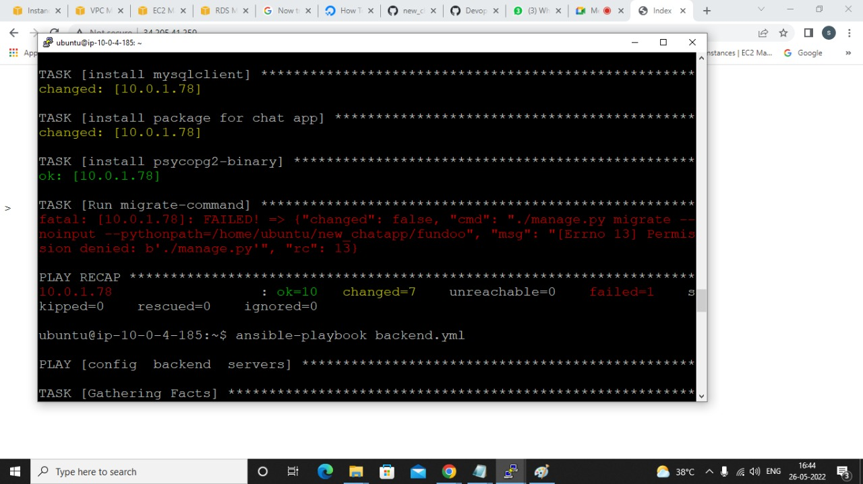

1.go to backend server and clone your gitub repository

2.change manage.py permission

Ls -lt

Chmod +x manage.py

Git add .

Git remote origin add

Git commit

Git push origin master

Change given changes

Add your etri repo name

Ex. Prarthana-git/new_chatapp

Give token instead of password